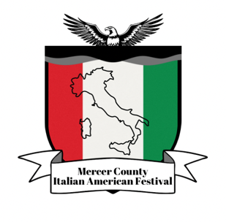
Mercer County Italian American Festival Association 2026 Scholarship Dinner Honoring: Distinguished supporter Dan Benson Mercer County Executive
April 30th 2026
Please support the MCIAFA’s annual scholarship awards by submitting "all" ads electronically, preferably as a Word document or JPG file and/or in PDF format. Printer reserves the right to edit or reduce size or eliminate any copy that does not meet advertising criteria. Ads will be printed in black & white or Color as received.
Advertisement for:  Full Page  Half Page  Quarter Page  Business Card Inside Covers:  Back Cover:  Center Pages – Ea. | Contribution:  $ 125.00  $ 75.00  $ 35.00  $ 50.00  $ 150.00  $ 250.00  $ 250.00 | Ad Size: | Please Check:
8” x 10” ______
8” x 5” ______
4” x 4” ______
1/8th page ______
Front – Back _____
8” x 10” ______
8” x 10” ______

Journal size is 8.5” by 11”. Ad sizes shown are live matter area for printing. If your material exceeds size, we will reduce it to fit. Please do not staple or tape ad copy or business card. Check X on the line
Sponsor/Company: ________________________________________________________________________ Name: ___________________________________________________________________________
Address: _____________________________________________________________________________________ City: _______________________________ State: ____________________________ Zip: __________________ Daytime Phone: ______________________________ Evening Phone: __________________________________ ***Ads submitted in Word or JPG and/or PDF electronically to agc44@optonline.net MAKE checks payable to –

MCIAFA Scholarship Fund – Attn. Rocco Riccio
1666 Hamilton Ave
Hamilton, NJ 08629
PHONE: 609-498-9245

QUESTIONS, contact Tony Celentano 609 510-7829
The printing DEADLINE for the Ad Book is Tuesday, April 16th, 2026
“All proceeds to benefit the MCIAFA Scholarship Fund”

